

**Boston University**

**Electrical & Computer Engineering**

**EC463 Capstone Senior Design Project**

**Problem Definition and Requirements Review**

**CyborgSax**

Submitted to

Name: Zach Lasiuk

Address: 100 5th Avenue, Floor 5  
Waltham, MA, 02451

Phone: 715-781-5409

Email : lasiukza@bu.edu

by

|  |
| --- |
|  |

Team Members

Raymond Liang rliang6@bu.edu

Esiri Madagwa Jr. esiri558@bu.edu

Tariq Ahsan tahsan@bu.edu

Qinglang Yu yqlbu@bu.edu

Andrew Zannetos andrewzz@bu.edu

Submitted: 10/08/2018

**Customer Sign-Off _______________________________________**

**CyborgSax**

**Table of Contents**

Project Summary 2

1 Need for this Project 3

2 Problem Statement and Deliverables 3

3 Visualization 4

4 Competing Technologies 5

5 Engineering Requirements 5

6 Appendix A References. 6

# **Project Summary**

The goal of CyborgSax is to design a system that can create visual and audio effects for a saxophone. The visual effects will be controlled by a microcontroller which will be either a Raspberry Pi or an Arduino and will be attached to the saxophone. The microcontroller will control the DSP for the audio effects, which will then be fed to the output of the speaker. The input audio will be taken by a microphone that will be attached to the saxophone. Examples of the requirements listed are LED lights blinking or other enhancing features that will be investigated later in the project for the visual effects portion, and a line level output for the audio effects. The tasks that need to be done include getting the DSP to manipulate the saxophone audio input and getting the LED lights to flash in response to the audio signals.

# **1 Need for this Project**

The motive behind this design project is to help our client Zach Lasiuk have visual lighting effects put on his saxophone as he plays and to have manipulate the audio input with some DSP that can be played to the output (the external speaker). Zach has started working on this project himself, however, he has had some difficulty getting his device to work. As a result he has submitted this project to the ECE department for the senior design students to help him fix the problem.

Our client Zach has mentioned that he has requested this design project for the purpose of having stunning audio and visual effects while he plays at gigs, which are live musical performances. There is no essential need for this product other than giving a more interactive and entertaining experience for people attending these live concerts. The reason behind this whole project is to give the audience at concerts a graphical representation of the music that they are hearing.

As a group, we discovered that disco lights may enhance audience’s experience at concerts. However, when the audience views something on stage, their eyes are focused on the performer, not on the lights on the ceiling. Our product then will provide a solution to deal with this problem.

# **2 Problem Statement and Deliverables**

The objective of this project is to enhance the music experience at live concerts both audibly and visually. A lot of people who perform at concerts play musical instruments. However, there is no interactive visual element on the individual instruments at these performances. The main purpose of this project is to give an even more enjoyable and sensually-stunning experience for the audience. The visual effects could be done with LED lights, and there is creative flexibility so long as the visual effects are cool and eye-catching. The music visualiser will be installed on the exterior of the saxophone and the microprocessor will deliver the audio effects such as distortion, reverb, delay and phaser.

Our client also requires deliverables and the main deliverables are the abilities for the system to be versatile and easy-to-use, regardless of the user and the environment it is in. There are two scenarios of where the system is going to be used; playing in the streets, and playing in a venue. While on the streets, the performer’s microphone will be attached to the saxophone and there will be a speaker attached to the saxophone as well. In a concert venue, such as the House of Blues Boston, the system will still utilize an attached microphone on the saxophone, however, there will be no speaker mounted to the saxophone - the sound from the wireless clip-on microphone will be sent to the numerous speakers that comprise the venue sound system. The main issue with street performances is portability, often times requiring external powered speakers to amplify the sound; with this portable system there is no need to have a huge plug-and-play speaker. The whole system will have to work with different kinds of saxophones and must remain stable in chaotic environments, such as where the performer will be moving around. The control box (the microprocessor) must be placed on the saxophone and must not get in the way of the performer.

While the musician is playing either out on the streets or in a concert venue, he or she would may want to manually control the visual and audio effects. This will be done via a keypad where the performer can control the visual effects and the audio effects. There will a requirement to have the audio latency will be less than 10 milliseconds. The microprocessor must have the ability to store pre-recorded song and sound sample for playback with the live saxophone input. All three aspects such as audio effects, visual effects and pre-recorded playback must all work in real time.

The main deliverables that must be accomplished are the basic visual and audio effects, which are two features of this project that are most important to the client. After we can get the main deliverables working, the next step is to enhance the visual effects to more than just flashing lights. We would like the visual effects to maybe include a video projection of visuals or possibly 3D holograms. Even though this task may seem like a challenge, it would be nice to implement them if we can get it to work as our client does want something cool and entertaining. In addition to the hologram/visuals that may be implemented, another add-on to the project that could increase the appeal of this product is having hand gestures as controls which will involve sensors detecting hand movements which will then be controlling the visual effects and audio effects. One last thing that the client did say we can add in as extra is CO2 cannon/cryo-gun attached to the saxophone that the performer can use.

# **3** **Visualization**

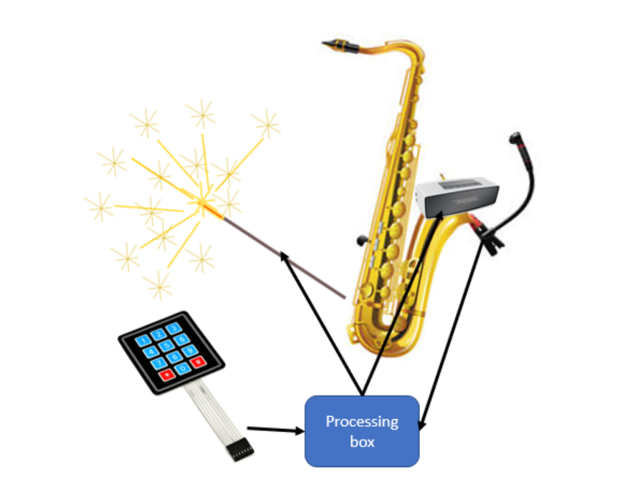

*Figure 1: This is a visualization of the proposed design for CyborgSax. A clip on microphone and controlling unit will send data to a wearable processor that will do dsp to create audio and visual fx and then output this through lights and a speaker. A key pad attached to the processor is used to control the mode of visual and audio output.*

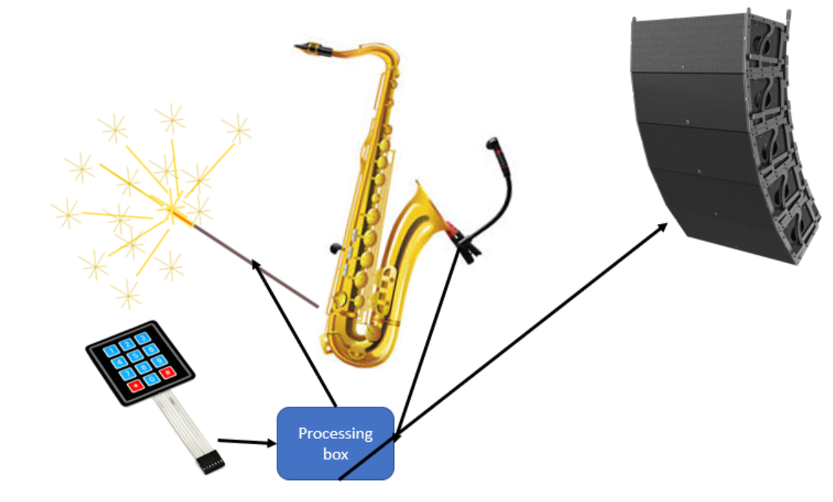

*Figure 2: The external audio output (external speaker) is added to the solution. This part will output the audio signal transmitted from the digital processor.*

# **4** **Competing Technologies**

There have been several products on the market that can do similar tasks in comparison to the project that our senior design team is going to do. Two of these products on the market include the JBL Pulse and the Creative Halo which are both speakers that will create visualisations based on audio input that gets fed to the system. Another product on the market is the Starburst disco ball which will project lights around the room according to what the music signals are.

There are multiple requirements for the JBL Pulse. The JBL Pulse is a speaker that has programmable LED lights which means you can adjust the settings of the LED lights to a certain preference if the user does not already like the way the current settings of the JBL Pulse. The JBL Pulse is meant to include bluetooth so the user can sync the device with the speaker wirelessly or the JBL Pulse can be synced with a wire. One last requirement for the Pulse is the battery life has to last for 5 hours. The second visual speaker that is also a competing technology is the Creative Halo which also includes a light show and has a slightly extended battery life of 8 hours. In addition, just like the Pulse the Halo will use bluetooth and can also be wired or wireless.

The next competing technology that is slightly different is the Starburst disco ball which will light up an entire room with lights. This system includes requirements such as lights that are red, green , blue ,white, yellow and purple and has a beam angle of one degree. To add on, instead of being wired like the previous two products this disco system is wired.

For our project the JBL Pulse and the Creative Halo are two similar products compared to the CyborgSax project that we are working on when it comes to requirements. Just like the JBL pulse the programmable LED lights or visual effects will be controlled by either hand gestures or a keypad. We plan to have the entire system wireless so there are no cords connecting to any power outlets which will mean that a battery pack of some sort will be used. One thing that we need to think of as incorporating as a requirement is a battery life length as the user will need to get an idea of how long the power is going to last for before the system shuts off.

# **5 Engineering Requirements**

**Visual System**

1. LEDs must be attached to the Saxophone.
2. Consider adding fancy features for the Visual output such as adding a blinking feature on the LEDs.

**Audio System**

1. Maximum allowed latency of 10ms (The lower, the better)
2. Audio Effects is controlled by the microcontroller. DSP will be outputted through the external speaker.
3. A sound balancer or a advanced amplifier is needed for the output.
4. Microphone sound collection from the saxophone must be done via clip on microphone (Sound input).
5. Basic audio effects will include distortion, octave effects, reverb and phasors.
6. There is no need for time signature changes.

**Signal Processing**

1. Processing Unit must be wearable/mountable to the Saxophone.
2. No laptop is allowed as processor for the solution. Alternatively, use Arduino or Raspberry Pi.
3. Processing unit must be battery/solar powered. It cannot rely on the outlet power.

**Power**

1. The whole system will be powered with a battery pack, no external power source such as power wall outlets is needed for the design except for the audio output (External speaker).
2. For the external speaker, it will be connected to wall outlets with a cable.

# **6 Appendix A References.**

"ADJ Starburst with 5x 15W HEX colored LEDs in a sphere effect." *ADJ.* Web. 8 Oct 2018.

<<http://www.adj.com/starburst>>

"Creative Halo Specs - CNET." *Product reviews, how-tos, deals and the latest tech news - CNET.*

Web. 8 Oct 2018. <<http://www.cnet.com/products/creative-halo-speaker-for-portable-use-wireless/specs/>>

"JBL Pulse Specs - CNET." *Product reviews, how-tos, deals and the latest tech news - CNET.*

Web. 8 Oct 2018.

<<http://www.cnet.com/products/jbl-pulse/specs/>>

Lasiuk, Zach . "Google Docs - create and edit documents online, for free.." *Google Docs.*

30 Sep 2018. Web. 8 Oct 2018. <<http://docs.google.com/document/d/1GQSIYTdezOrjVNDvRmnhC7kvA3HrTr83Y1-KseMIv4E/edit>>

Liang, Raymond . "Google Docs - create and edit documents online, for free.." *Google Docs.*

28 Sep 2018. Web. 8 Oct 2018. <<http://docs.google.com/document/d/1bM-aHF--WimPj-89cWhn-Bsv0Oxr-RS6LF6l-uW4v3w/edit>>